Repeat Until Practice
For each of the following, keep track of the value of the variable x in the provided chart:
iterations | value of x
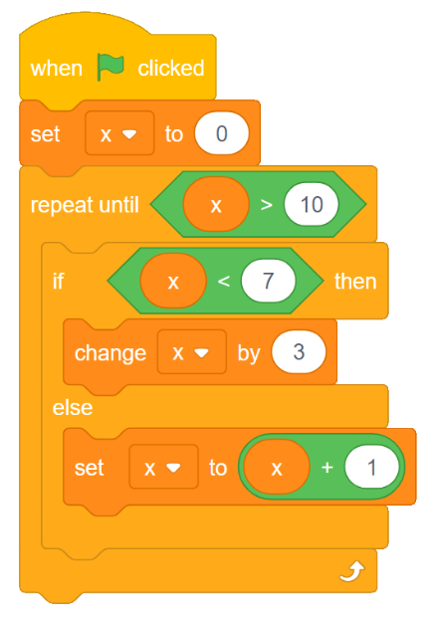
Question 1:

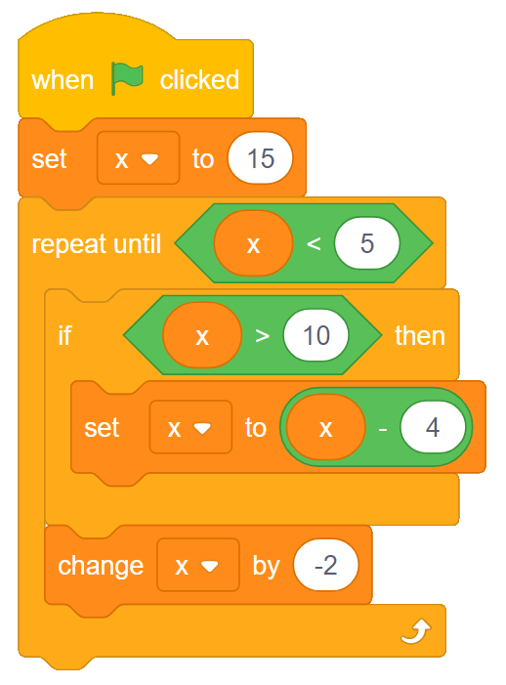
Question 2:
iterations | value of x

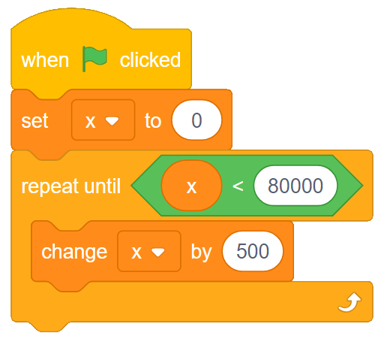
Question 3:
iterations | value of x

